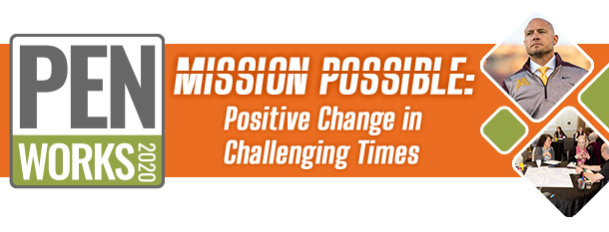
September 23, 2020 -- PENworks 2020
8:15am – 8:30am | Welcome and Opening Comments
8:30am – 9:00am | Beyond Grit: Embracing Passion & Perseverance to Gain the High Performance Edge  Dr. Cindra Kamphoff
9:00am – 9:15am | Break & Transition – Consider Visiting Exhibition Hall or thePEN Lounge!
9:15am – 10:00am | Intensive Session  Leading with Resiliency in Turbulent Times  Studer Education (formerly Pewaukee Schools, WI)  Dr. JoAnn Sternke | Sustaining Your PI Journey – A Community Engagement Strategy at Excelsior Springs MO  Communities of Excellence 2026  Stephanie Norling, Kim Halfhill, and Molly McGovern | Rapid Planning: Using a Weekly Direction Setting Process  General Mills  Dan Maus & Collin Bonde | Better Tomorrow than Today: Inclusion, Diversity and Racial Justice  Circle of Friends, Rapid City  Malcom Chapman | PENLounge – Networking, Facilitated Sharing  It’s a Marathon: Managing Stress, Staying Resilient
10:00am – 10:15am |  | Break & Transition
10:15am – 11:00am |  | MN Performance Excellence Award Winner Panel  Austin Public Schools  MN Pollution Control Agency  Walden University, College of Mgmt. | Managing Stress & Conflict, Staying Resilient, Navigating Grief and Maintaining Mental Health  Brianna Harrington  Anna Maravelas  Shannon Murphy Robinson | Inclusion: It Doesn’t Happen by Accident  Rochester Public Library  Audrey Betcher | PENLounge – Networking, Facilitated Sharing  Best Practices in Communication w/a Virtual Workforce & Zoom Overload
11:00am – 11:15am | Break & Transition – Consider Visiting Exhibition Hall or the PENLounge!
11:15am – 12:15am | Baldrige Keynote Journeys: Adventist Health White Memorial (CA), Illinois Municipal Retirement Fund (IL),  Mary Greeley Medical Center (IA), Alamo Colleges District (TX)
12:15am – 1:00pm | Break & Transition – Consider Visiting Exhibition Hall or the PENLounge!
1:00pm – 1:30pm | 2019 Minnesota Quality Award Ceremony; Governor Walz invited
1:30pm – 1:45pm | Break & Transition – Consider Visiting Exhibition Hall or the PENLounge!
1:45pm – 2:30pm | Intensive Session  Baldrige Panel –  Leading Through Crisis  Adventist Health White Memorial, Illinois Municipal Retirement Fund, Mary Greeley Medical Center,  Alamo Colleges District  Moderator:  Dr. JoAnn Sternke | Performance Management Using Design Thinking  Children’s Minnesota  Phil Zeccardi | Co-Creating Government: How Innovation by Design is Transforming Hennepin County  Hennepin County  Amy Schrempp and Khalid (Kay) Adam | The Imperative for Diversity, Inclusion & Racial Equity  Center for Economic Inclusion  Tawanna Black | PENLounge – Networking, Facilitated Sharing  Why Baldrige? Why Now?  Surviving Today;  Thriving Tomorrow
2:30pm – 2:45pm |  | Break & Transition – Consider Visiting Exhibition Hall or the PENLounge!
2:45pm – 3:30pm |  | Community Collaboration  Cradle to Career  Julie Brock | Ensuring Employee Wellness & Employee Engagement in These Challenging Times  3M  Dr. Oyebode Taiwo | PENLounge – Networking, Facilitated Sharing  Exploring How PEN Can Support Your Organization | PENLounge – Networking, Facilitated Sharing  Diversity, Equity, Inclusion
3:30pm – 3:35pm | Break & Transition
3:35pm – 4:10pm | Creating a Culture of Winners  Coach PJ Fleck, Head Coach, Minnesota Gophers Football Team
4:10pm – 4:40pm | Learning Disguised as Entertainment: Laughter is the Best Medicine  Performed by Theatre of Public Policy
4:40pm – 4:45pm | Closing Comments
4:45pm – 5:30pm | PENLounge Virtual Happy Hour, Visit Exhibitors

