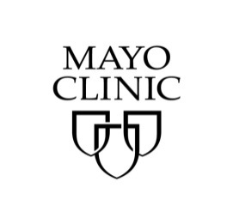
Mayo School of Continuous Professional Development (MCSCPD)
Completing Evaluations, Claiming Credit and Printing the Record of Attendance

Instructions:
- Start at https://ce.mayo.edu/
- If you are not already logged in, click LOG IN (upper right corner) – or – if you have not used our system before, you need to create your profile first.
IMPORTANT! You must use the same email that you used when you registered so that the system will match up correctly. If you choose to use a different email, inform smith.nicki2@mayo.edu.
- Once logged in…select My Account (upper right corner), My Courses, and then Registered Courses

Click the Activity title: XVII th International Myeloma Workshop 2019 to be taken to the course page which will look like this:
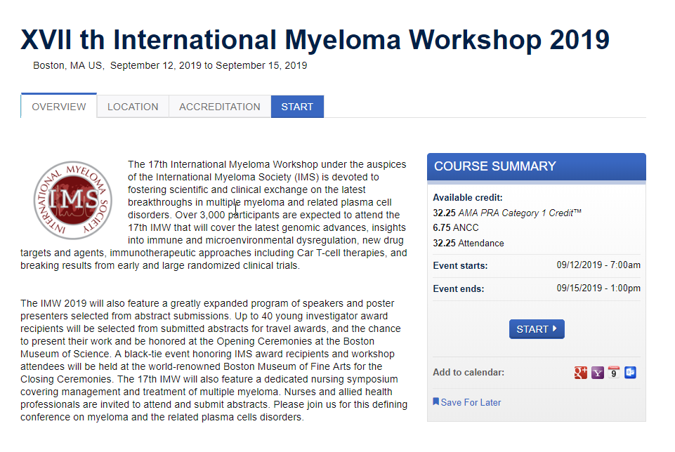
- Click START and Read the Course Instructions
6. Click START COURSE (lower right corner)
  - Complete any faculty evalautions for the days you attended the course. Due to the large program, even if you are not able to rate all the sessions you attended, rating at least a handful of them will be helpful.
  - Enter the number of credits claimed up to the maximum and check the box next to the “I agree” statement.
    - The AMA credit maximums by day are as follows:
Thursday - 7.75
Friday Plenary - 5
Friday Ballroom – 0*
Saturday Plenary - 6.25
Saturday Ballroom – 0*
Saturday Room 210 – 0*
Sunday - 3.5

*Credit is not available for abstract presentations.
    - If you attended only the nursing symposium, you should not claim any AMA PRA Category 1 CreditTM but can claim the ANCC credit.
ANCC
Mayo Clinic College of Medicine and Science designates this live activity for a maximum of 4.75 ANCC nursing contact hours. Nurses should claim only the credit commensurate with the extent of their participation in the activity.
    - If you don’t need AMA or ANCC credit, claim Attendance.
    - Deduct hours (in .25 increments) accordingly if you arrived late or left early.
The screen will look similar to the below:

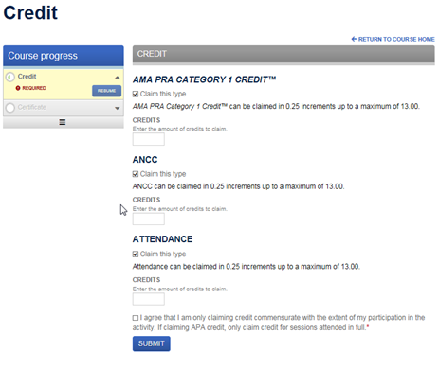

  - Click SUBMIT then click NEXT, this will take you to the Certificate download.
  - Click the Download certificate link to generate a pdf. At this point you can open, print, e-mail or save the certificate to your computer.
  - Your certificate will remain in your account on ce.mayo.edu under MY ACCOUNT, MY COURSES, TRANSCRIPT.

Help/Support:
- Setting up Account - Mayo Clinic Education Technology Center at etc@mayo.edu or 507.266.9087
- If you opt to use a different email address compared to the one you registered with, inform smith.nicki2@mayo.edu

