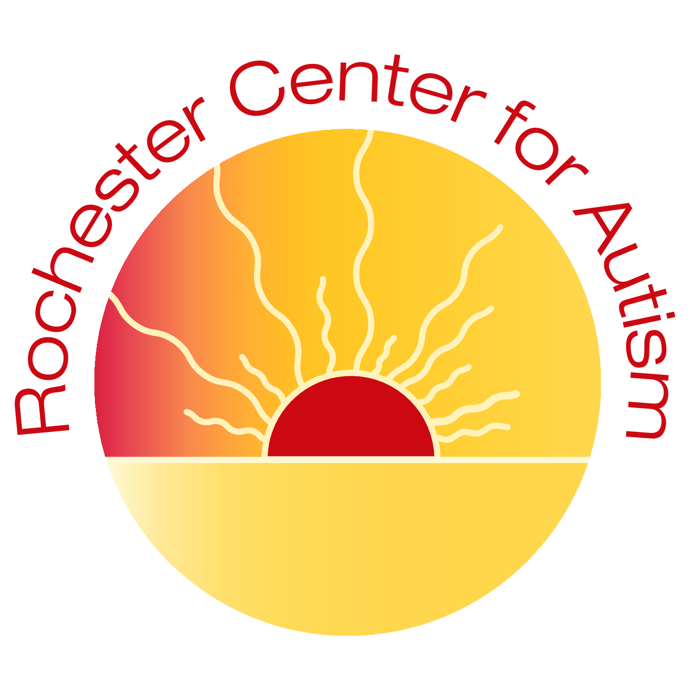
In-Center COVID-19 Preparedness Plan
Rochester Center for Children/Rochester Center for Autism (RCC/RCA)
3640 9th St NW; Rochester, MN 55901
(507) 424-3234
This document includes protocols and practices in place at the Rochester Center for Children (RCC)/ Rochester Center for Autism (RCA) to prevent the spread of the COVID-19 virus within our therapy center. These protocols are based on recommendations from the Centers for Disease Control and Prevention and the Minnesota Department of Health. The Rochester Center for Children/ Autism will evaluate the COVID-19 plan through weekly meetings. Supervisors will talk with parents regularly, sharing necessary changes. Changes will be communicated on a monthly-basis or as needed. RCC/ RCA will communicate consistently with local organizations such as public health.
STAFF WORKING IN-CENTER:
• Staff will call RCC/ RCA daily to complete the COVID-19 Health Screen to determine if they are able to work.
• The center will be locked during business hours. The front desk phone number is located on the front door for access if necessary.
STAFF WOKRING IN-CENTER PROTOCOLS:
• Staff enter via designated entrance.
• Staff wash their hands immediately upon entering the building. *Per MN Department of Health: Handwashing for at least 20 seconds has been proven to be the most effective way to the protect against transmission of the COVID-19 virus.
• When hand sanitizer is used, we ensure it contains at least 60% alcohol. It will be supervised when used and placed out of reach when not in use.
• Staff will get their temperature taken upon arrival.
• Masks are required for staff, maintenance/ service providers entering the building. *MN Executive order 20-81, effective 7/25/2020 requires use of masks for all businesses.
• Staff have eyewear and face shields available if they prefer to use them.
• The center meets current HVAC requirements. We also have air purifiers and fans for extra circulation at the center.

ARRIVAL AT RCC/ RCA:
• Parents are required to call into the Center to complete the COVID-19 Health Screening prior to the start of their child(ren)’s therapy session. Parents are to call the Center prior to their child(ren)’s scheduled therapy time if their child(ren) will not be coming in for the day.
• Social distancing practices will be followed.
• Clients will enter one at a time and will be picked up one at a time except client’s arriving and departing via transportation companies.
• A designated staff will be in the front entrance area or outside awaiting client arrivals.
• Upon client arrival, designated staff will take the client’s temperature prior to the client exiting the vehicle and complete the COVID-19 Health Screen if they have not called ahead of time.
• Assigned staff will be notified to go out to the vehicle to greet the client.
CLIENTS IN-CENTER PROTOCOLS:
• Staff will bring the client to the restroom or handwashing station.
• Staff and client will immediately wash hands.
• Backpacks and personal belongings will go with the client to their locker or with to their designated therapy area.
• Clients will stay in their designated therapy areas throughout the day, except to use the restroom, or during their scheduled outside park time, or gross motor room time.
• Staff and clients will wash their hands after each use of the restroom.
• Client snack and lunch times will take place in the designated area. Staff and clients will wash their hands before and after eating. Staff will clean and sanitize the tables and chairs before and after eating.
• No small groups will be held outside of designated therapy areas unless social distancing rules can be implemented.
• Toys will be cleaned, sanitized, and disinfected daily.
• The Gross Motor Room and Outside Park will only be used on a scheduled basis. Thorough disinfecting will be done after each use of the park and the gross motor room equipment used.
• Staff will report any of the COVID-19 Health Screening symptoms to their child(ren)’s lead therapist to monitor clients throughout the day for any sign of illness.
• Clients exhibiting any symptoms on the health screen, will be sent home. The child will be isolated and supervised until they are picked up. Parents will be contacted and must arrange for their child to be picked up.
• Additional handwashing by clients and staff will occur throughout the day per established hand washing protocols.
DEPARTURE:
• Social distancing practices will be followed when possible.
• Clients will depart one at a time except client’s leaving via transportation companies.
• A designated staff will be in the front waiting area or outside awaiting parent arrivals and notifying staff. Parents or transportation company staff will call the center when the ride has arrived for pick-up.
• Staff and clients will wash their hands before leaving the building.
• Parents and drivers will remain in or near the vehicle and staff will bring the child out to the vehicle.
DAILY SANITATION PROCEDURES DURING COVID-19:
• Thermometers will be disinfected regularly.
• Each location will utilize a daily cleaning/ disinfecting checklist to ensure all areas are properly cleaned.
• Cleaning means washing hard surfaces with soap and water or spraying sanitizer and wiping the area with a clean paper towel.
• Disinfecting products will be used to thoroughly wet toys, food service areas or anything that could be placed in the mouth and allowed to air dry.
• Disinfectant is used to thoroughly wet all other surfaces and allowed to air dry.
LUNCH/BREAK TIMES:
• Social distancing will be practiced.
• Staff will wash hands as they enter the staff break area and before leaving the area.
• Staff will clean and sanitize tables after each use.
END OF DAY:
• Each therapy location, toys within the area and all frequently touched surfaces throughout the Center will be cleaned and then sanitized/disinfected midday and at the end of the day.
• Areas used will be vacuumed daily.
• Bathroom toilets, countertops, paper towel holders, handles, etc… cleaned and disinfected.
• Bathroom and kitchen floor mopped daily.
• Staff break room countertops, tables, microwave and refrigerator handles cleaned and sanitized.
• Center entrance and exit doors cleaned and disinfected.
• Trash removed
POSITIVE COVID-19 RESPONSE PLAN:
• Employee or child has a positive COVID-19 test result.
• Employee will contact RCC/ RCA and talk to the Manager or HR.
• Parents notify RCC/ RCA immediately
• The Manager/Supervisors will contact employee/parent directly.
• Discuss start of symptoms
• Discuss contact with pod/employees/areas of the center.
• RCC/ RCA will follow the recommendations of the CDC: Companies do not necessarily need to close after a person with confirmed or suspected COVID-19 has been in a company building. The area(s) used or visited by the ill person should be closed for 24 hours or as long as possible. Open outside doors as much as possible ensuring that doing so does not pose a safety risk to children using the facility (i.e. make sure that children are not able to enter the closed off area) and use ventilating fans to increase air circulation in the area. Once the area has been appropriately disinfected, it can be opened for use.
• https://www.cdc.gov/coronavirus/2019-ncov/community/disinfecting-building-facility.html •
The Center Manager/ HR will develop and send out information to clients and staff which will be categorized as direct or indirect contact and communicate with our local public health agency.
• This communication will be in person and/or electronically to personal emails. High risk individuals/families will be identified, and attempts will be made to contact them directly via in person or phone guiding you to the next steps.
• One week following the confirmed positive case, further communication will be sent out updating staff and parents of the current status.
CONTACT WITH A POSITIVE COVID-19 PLAN
• Employee or child had contact with a known positive case.
• Employee will contact RCC/ RCA and talk to the Manager or HR.
• Parents notify RCC/ RCA immediately
• The Manager/Supervisors will contact employee/parent directly.
• Employee or parent will contact medical professional for guidance on next steps.
RCC/ RCA COVID-19 HEALTH SCREEN:
All staff and clients will complete a health screen each day by calling the Center. The health screen questions will be asked, and temperatures will be taken for both staff and children upon arrival at a therapy center. A child or staff will be immediately sent home if there are concerns of illness. Please contact the Center prior to your child(ren)’s scheduled arrival time to notify us if your child has any symptoms of illness. Then call a health care professional to seek medical recommendation on return to center time frame. Next, notify RCC/ RCA of health care professional’s recommendation.
FIELD TRIPS/ EVENTS
Field Trips and all Center events are on hold to prevent the spread of the COVID-19 virus.

