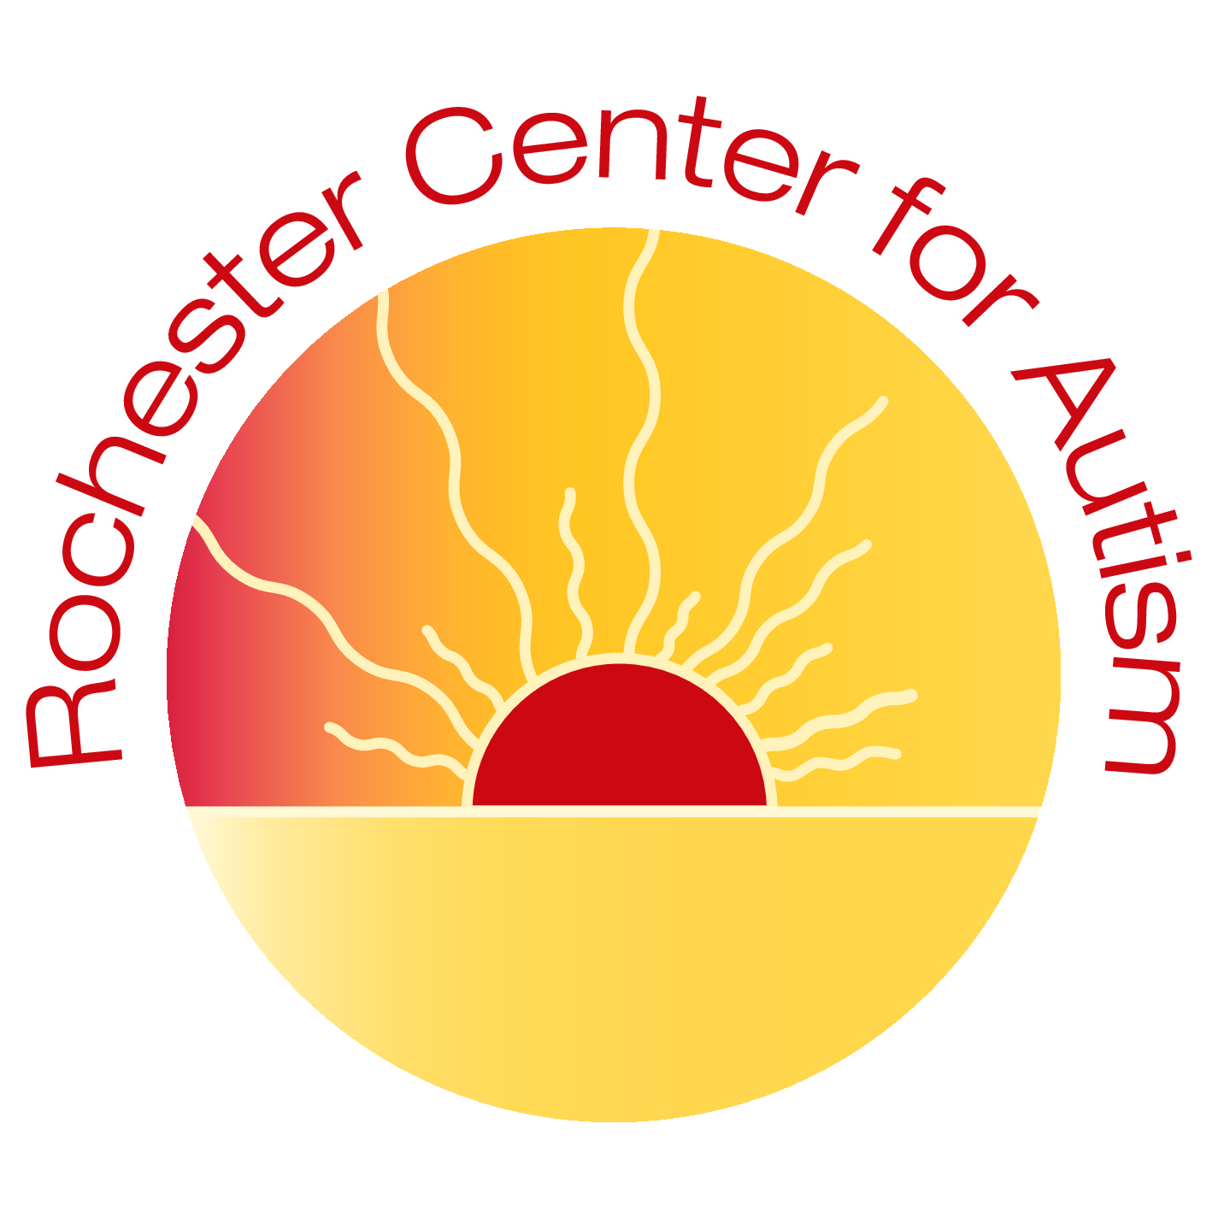
In-Home COVID-19 Preparedness Plan
Rochester Center for Children/Rochester Center for Autism (RCC/RCA)
3640 9th St NW; Rochester, MN 55901
(507) 424-3234
This document includes protocols and practices in place at the Rochester Center for Children (RCC)/ Rochester Center for Autism (RCA) to prevent the spread of the COVID-19 virus in-home. These protocols are based on recommendations from the Centers for Disease Control and Prevention and the Minnesota Department of Health. The Rochester Center for Children/ Autism will evaluate the COVID-19 plan through weekly meetings. Supervisors will talk with parents regularly, sharing necessary changes. Changes will be communicated on a monthly-basis or as needed. RCC/ RCA will communicate consistently with local organizations such as public health.
STAFF WORKING IN-HOME:
Staff will call RCC/ RCA daily to complete the COVID-19 Health Screen to determine if they are able to work.
STAFF WOKRING IN-HOME PROTOCOLS:
• Staff enter via designated entrance of the home.
• Staff wash their hands immediately upon entering the building. *Per MN Department of Health: Handwashing for at least 20 seconds has been proven to be the most effective way to the protect against transmission of the COVID-19 virus.
• When hand sanitizer is used, we ensure it contains at least 60% alcohol. It will be supervised when used and placed out of reach when not in use.
• Staff will get their temperature taken upon arrival.
• Masks are required for staff.
• Staff have eyewear and face shields available if they prefer to use them.
ARRIVAL AT THE CLIENT’S HOME:
• Parents will complete the COVID-19 Health Screening prior to the start of their child(ren)’s therapy session. Parents are to call the Center prior to their child(ren)’s scheduled therapy time if their child(ren) will not be having therapy for the day.
• Upon staff arrival, all family members will take their temperatures prior to the start of the therapy session.
CLIENTS IN-HOME PROTOCOLS:
• Staff and client will immediately wash hands.
• Staff and clients will wash their hands after each use of the restroom.
• Toys will be cleaned, sanitized, and disinfected daily.
• Staff will report any of the COVID-19 Health Screening symptoms to the parent or caregiver to monitor clients throughout the day for any sign of illness.
• Clients exhibiting any symptoms on the health screen, will not be able to have therapy that day. Center staff will follow-up with the family regarding the next action steps.
• Additional handwashing by clients and staff will occur throughout the day per established hand washing protocols.
DEPARTURE:
• Staff and clients will wash their hands before leaving the home.
DAILY SANITATION PROCEDURES DURING COVID-19:
• Thermometers will be disinfected regularly.
• Each location utilized will require cleaning/ disinfecting daily.
• Cleaning means washing hard surfaces with soap and water or spraying sanitizer and wiping the area with a clean paper towel.
• Disinfecting products will be used to thoroughly wet toys, food service areas or anything that could be placed in the mouth and allowed to air dry.
• Disinfectant is used to thoroughly wet all other surfaces and allowed to air dry.
END OF THE SESSION:
• Toys and items within the area and all frequently touched surfaces within the therapy area will be cleaned and then sanitized/disinfected at the end of the therapy session.
POSITIVE COVID-19 RESPONSE ACTION PLAN:
• Employee or child has a positive COVID-19 test result.
• Employee will contact RCC/ RCA and talk to the Manager or HR.
• Parents notify RCC/ RCA immediately
• The Manager/Supervisors will contact employee/parent directly.
• Discuss start of symptoms
• RCC/ RCA will follow the recommendations of the CDC and Public Health.
• The Center Manager/ HR will develop and send out information to clients and staff which will be categorized as direct or indirect contact.
• This communication will be in person and/or electronically to personal emails. High risk individuals/families will be identified, and attempts will be made to contact them directly via in person or phone guiding you to the next steps.
• One week following the confirmed positive case, further communication will be sent out updating staff and parents of the current status.
CONTACT WITH A POSITIVE COVID-19 PLAN
• Employee or child had contact with a known positive case.
• Employee will contact RCC/ RCA and talk to the Manager or HR.
• Parents notify RCC/ RCA immediately
• The Manager/Supervisors will contact employee/parent directly.
• Employee or parent will contact medical professional for guidance on next steps.
RCC/ RCA COVID-19 HEALTH SCREEN:
All staff will complete a health screen each day by calling the Center. Each client will complete the health screen with staff upon arrival. The health screen questions will be asked, and temperatures will be taken for both staff, the client, and family members upon arrival at the client’s home. A staff will be immediately leave the home if there are concerns of illness. Please contact the Center prior to your child(ren)’s scheduled arrival time to notify us if your child has any symptoms of illness. Then call a health care professional to seek medical recommendation on return to center time frame. Next, notify RCC/ RCA of health care professional’s recommendation.
FIELD TRIPS/ EVENTS
Field Trips and all Center events are on hold to prevent the spread of the COVID-19 virus.

