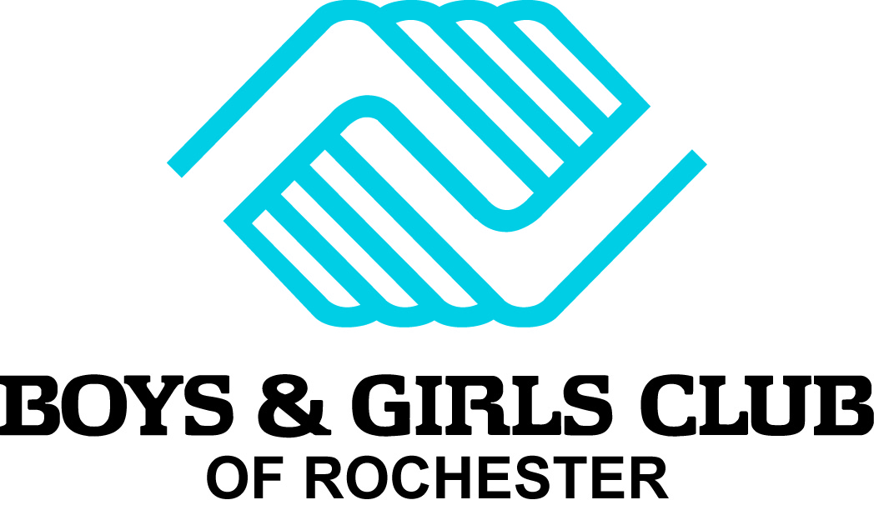
Blue Jeans for Blue Doors
Program Overview
© 2012 Boys & Girls Clubs of America. All rights reserved.

When: June – July 2015

What: A week or day-long, fun method of raising funds to support Boys & Girls Club of Rochester while boosting employee morale at the same time. The Blue Jeans for Blue Doors program is a turnkey way to get your employees involved in your BGCR partnership, while promoting teamwork and community involvement.

How it Works: For a small donation (suggested amounts: $25 for one week or $5 for one day), employees get to wear jeans at work during Blue Jeans for Blue Doors Week. It’s easy, and there is no cost for companies to participate. In fact, Boys & Girls Club of Rochester will supply all of the necessary items to kick off a successful Blue Jeans for Blue Doors campaign, including:

•Recruitment tools, such as email templates, social media content, fliers and more
•Step-by-step implementation tips
•Recognition tools and templates to thank participants
•We want to make it fun and easy for our corporate partners and all of their employees to participate!

Who Benefits: Funds raised through this program will benefit Boys & Girls Club of Rochester.

How You Can Participate: Getting started is easy! Please contact Chad Behnken at 507-536-3132 or CBehnken@thinkbank.com or Melissa Dickison at 507-529-2280 or MDickison@thinkbank.com and let him know your company would like to participate. A complete tool kit with fundraising resources will be provided. Let us know if you’d like to see the tool kit!

Blue Jeans for Blue Doors
Partner Tool Kit
© 2012 Boys & Girls Clubs of America. All rights reserved.
Thank you for participating in Blue Jeans for Blue Doors during the months of June & July 2015 to support Boys & Girls Club of Rochester. The program encourages employee engagement in our partnership, while promoting teamwork and community involvement.

Getting Started
Select a captain in each corporate office to:
- Review the materials in this tool kit.
- Print and display the promotional materials within the office/location (or request from BGCR).
- Recruit co-workers to participate.
- Distribute recognition icons – stickers or badges to thank individuals who sign up.
- Facilitate payments back to Boys & Girls Club of Rochester.

Once captains are selected, use the following attached resources to promote and implement Blue Jeans for Blue Doors:

Recruitment Tools
- Recruitment Email Template
- Encouragement Email Template
- Break room Flier
- Paycheck Stuffer

Program Management
- Sign-up Sheet
- Goal-Tracker Flier
- Recognition Icons – Stickers/Badges
- Thank-You Email Template

Collecting Funds:
- Gift Collection Card (preferred)
- Tax Receipt Template
- Investment Summary Document

Program Implementation Tips

Getting Employees Excited About the Program
- Notify people at least two weeks in advance and send reminders as Blue Jeans for Blue Doors approaches.
- Include Blue Jeans for Blue Doors paycheck stuffers in paychecks or employee mailboxes.
- Post recruitment fliers in the break room or other public space.
- Track participants and their donations using the sign-up sheet.
- When they sign up, give each participant a recognition badge or sticker to wear or post in their workspace. This will acknowledge them and help spread the word.

Creative Ideas
- Host a kick-off event or announce the program at a staff meeting to help promote sign-ups.
- If multiple sites are involved in your company, have a competition between each location. Offer a paid half-day off or other incentive.
- Motivate employees further by offering to match the funds they contribute. Is your office already casual? You can still invite your employees to participate during Blue Jeans for Blue Doors Week. Get creative! (For example, participants could wear their favorite team colors, wear flip-flops, or wear blue in support of Boys & Girls Club of Rochester.)

Running the Program
- Use the sign-up sheet(s) to track participants.
- You can set up donation amounts that make the most sense for your company. Suggested donation amounts are:
  - $25 donation: Employees can wear jeans the entire week.
  - $5 donation: Employees can wear jeans one day during the week.
- Encourage participants to pay upon signing up.
- BGCR would like to recognize your employees for their donation as well as give them a tax receipt. Please ask employees to use the gift collection cards and return in sealed envelopes provided by BGCR (preferred) or use the tax receipt template attached.
- Use materials to kick off Blue Jeans for Blue Doors Week and remind the participants to wear their jeans (you can print yourself or request from BGCR using the request form attached).

Wrapping Up

- Be sure to recognize all participants at the end of Blue Jeans for Blue Doors Week. (Use the email template provided)
- When you have collected all funds from participants, please complete the investment summary form and send it, along with a check for any donations not accompanied by a gift card, indicating the total investment amount, to the address listed below:

Jennifer Teske
Director of Philanthropy
Boys & Girls Club of Rochester
1026 East Center Street
Rochester, MN 55904

If possible, please send funds to Boys & Girls Club of Rochester within one week of completing your campaign or by July 24, 2015. If you have any questions about the donation process, you can reach Jennifer Teske, Director of Philanthropy, by email at jteske@bgclubroch.org or simply call 507-287-2311.

Blue Jeans for Blue Doors
Program Resources
© 2012 Boys & Girls Clubs of America. All rights reserved.
Order the following program resources by filling out the request form on page 1:

Recruitment Tools:
- Recruitment Email Template- pg. 2
- Encouragement Email Template- pg. 3
- Break room Flier- pg. 4
- Paycheck Stuffer –pg. 5

Program Management:
- Sign-up Sheet- pg. 6
- Goal-Tracker Flier- pg.7
- Recognition Icons – pg. 8 & 9
- Appreciation Email Template- pg. 10

Collecting Funds:
- Gift Collection Card – pg. 11
- Tax Receipt Template- pg. 12
- Investment Summary Document – pg. 13


Blue Jeans for Blue Doors
Program Resources
Request Form
© 2012 Boys & Girls Clubs of America. All rights reserved.
Thank you for participating in Boys & Girls Club of Rochester’s Blue Jeans for Blue Doors campaign. Please complete the form below and return it to Jennifer Teske at jteske@bgclubroch.org with your promotion requests at least 48 hours prior to the date that you need the materials.

Company Name: _______________________________________________________

Captain Name: _______________________________________________________

Phone: ____________________ Email: ___________________________

Date (s) of your company BJBD campaign: __________ Number of employees _______

Date promotional materials needed: __________

These are the promotional materials that I need and the quantity needed of each:

_____ Break room Flier- pg. 4

_____ Paycheck Stuffer –pg. 5

_____ Sign-up Sheet- pg. 6

_____ Goal-Tracker Flier- pg.7

_____ Recognition Stickers –pg. 8

_____ Gift Collection Cards with Envelopes– pg. 10

_____ Tax Receipt Template- pg. 11

Tell us about your campaign (special requests/creative modifications/photo opportunities, etc.): _______________________________________________________________________________________________________________________________________________________________________________________________________________
1

Recruitment Template Email

Use this suggested email content to announce Blue Jeans for Blue Doors to your employees.

Wear Jeans to Support a Great Cause!
<Company> is a proud supporter of Boys & Girls Club of Rochester! We’re helping to build great futures for young people in our community! You can help, too, by making a small donation to wear blue jeans during Blue Jeans for Blue Doors Week, <insert your dates>. This fun new program is called Blue Jeans for Blue Doors.
Why: Because Boys & Girls Club of Rochester cares about kids, and so do we!
Who Benefits: Funds raised through this program will benefit Boys & Girls Club of Rochester.

How to Participate:
Sign up today! Donate <$X> to wear jeans for a day or <$X> for the whole week. Please see <Insert Company Contact Name> for more information.

E-mail Template Header

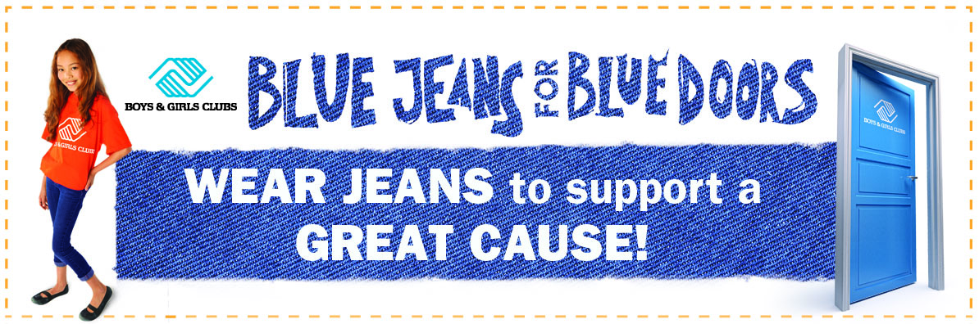

2
Encouragement Template Email

Subject line: Blue Jeans for Blue Doors Week: Are YOU wearing jeans?

Next week is Blue Jeans for Blue Doors Week! If you’re participating in our fun Blue Jeans for Blue Doors campaign, don’t forget to wear your jeans.

Together we've raised <$amount> for Boys & Girls Club of Rochester.

<Company> has supported Boys & Girls Club of Rochester for X years. Together, we <Insert details about your partnership>.

Please, join us in supporting Boys & Girls Club of Rochester and help open the door to a child’s future. If you haven’t already, contact <Insert Team Captain’s Name> at <Insert Contact Information> to sign up.

3
4
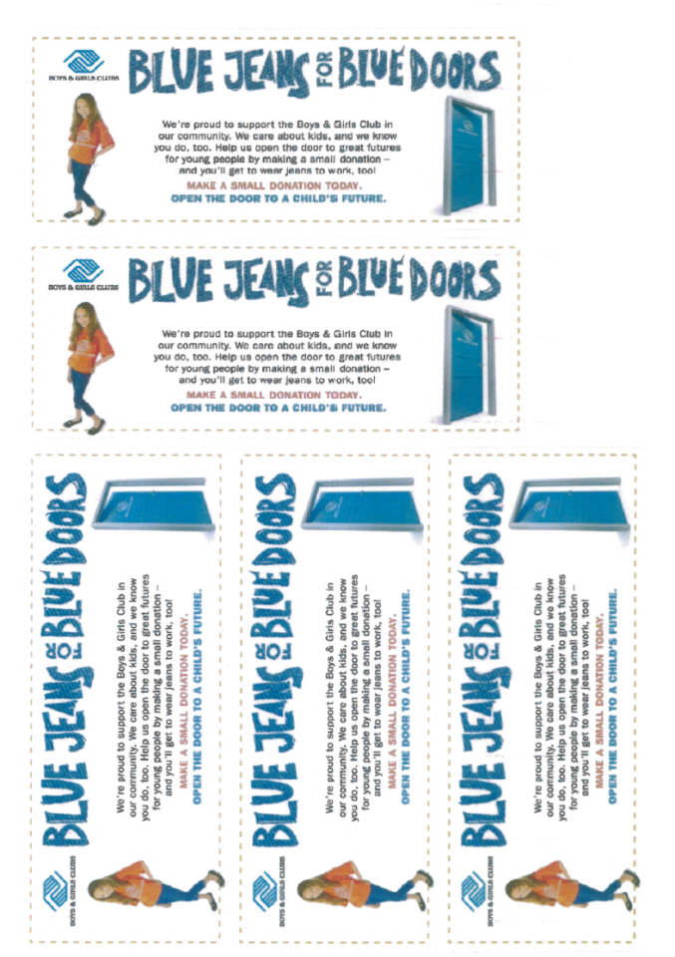

5

6

7

8
9

Appreciation Template Email

Subject line: You Made a Difference!

Thank you to everyone who participated in our fantastic Blue Jeans for Blue Doors campaign for Boys & Girls Club of Rochester. Because of you, we raised <$amount> to help start great futures for young people in our community.

Our sincere appreciation to everyone who donated:

<List names>

You make a difference for kids!

Sincerely,

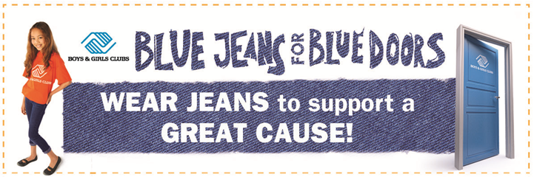

10

11

12
Investment Summary
Thank you for participating in Boys & Girls Club of Rochester’s Blue Jeans for Blue Doors campaign. We hope your employees enjoyed going casual while supporting our mission. Please complete the form below and return it with your donations. We appreciate your insight and hope you will participate again next year!
Please print this form and mail a completed copy to Boys & Girls Club of Rochester at the address referenced below.
A contribution of $_____________________________________
Methods of Payment:
Check/Money Order Payable to:
Boys & Girls Club of Rochester
Jennifer Teske
1026 East Center Street
Rochester, MN 55904
507.287.2311

Name: _________________________________________
Address 1: ______________________________________
Address 2: ______________________________________
City: ___________________________________________
State, Zip Code: __________________________________
Email: __________________________________________
***Your gift helps Boys & Girls Club of Rochester provide the life-changing programs and guidance that make our Club successful. Thank you for your support.
By providing us with your email address you will automatically receive news & updates from Boys & Girls Club of Rochester. If you would prefer not to receive updates from the Boys & Girls Club of Rochester via the email address provided, please check the box below.
I prefer not to receive emails from then Boys & Girls Club of Rochester. 13

