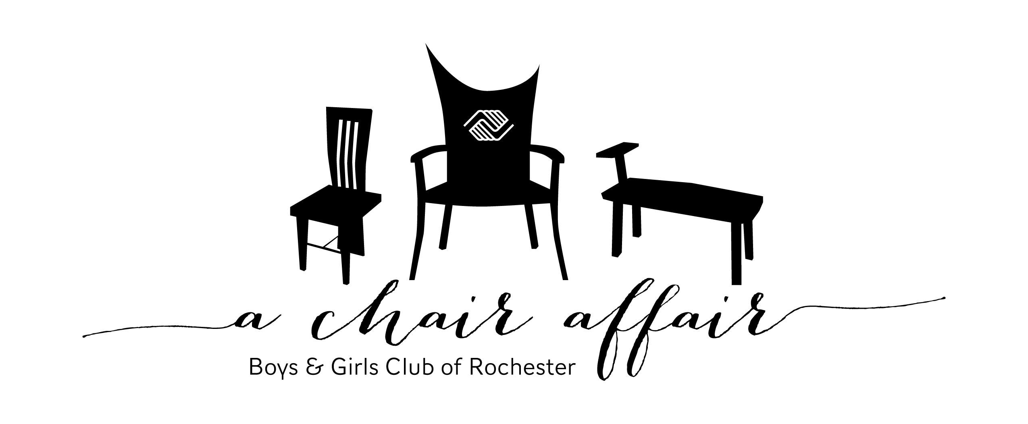
Auction Donation Form

A Chair Affair continues to be a tremendous success because of your generosity. The live and silent auction portion of this event is a critical part of our revenue. A Chair Affair’s success allows Boys & Girls Club of Rochester to continue programs and services to youth who need it most.
Please consider submitting an item to our A Chair Affair auction. Any item suitable for silent or live auction (sporting event tickets, gift certificates, wine, unique treasures, experiences, gift baskets, etc.) is appreciated and tax deductible.
Things you should know…
- Items valued at $1,000 or greater will receive a complimentary VIP ticket to the event ($125 value).
- Live auction packages will also be prominently displayed on the event website, www.achairaffair.org.
- Our tax exempt number is 41-1945875.

Name (how you would like to be recognized) _______________________________________________________
Contact Name (for businesses) ______________________________________ Phone ___________________
Address _________________________________________________ E-mail __________________________
Item(s) – please include any restrictions/expirations dates etc. | Estimated Value of Item(s)

Item Delivery – for marketing purposes, please have items to Club by 4pm on January 29, 2016.
__I will deliver to Boys & Girls Club
Please return form to:
Attn: Jessica Sund
Boys & Girls Club of Rochester
1026 East Center Street
Rochester MN 55904
or: jsund@bgclubroch.org

__Item will need to be picked up
__Item has been given to A Chair Affair
committee member
If you have questions or would like to find out about other investment opportunities, contact Jessica at 507.287.2316 or jsund@bgclubroch.org
Thank you for helping the youth in our community BE GREAT.
www.bgclubroch.org

