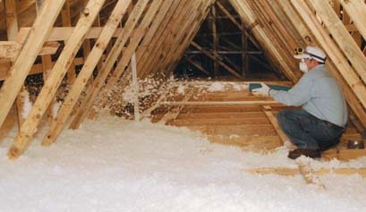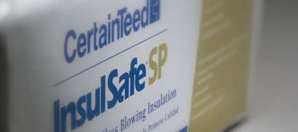
Insulsafe SP – 31lb Bag
Open Attic Application
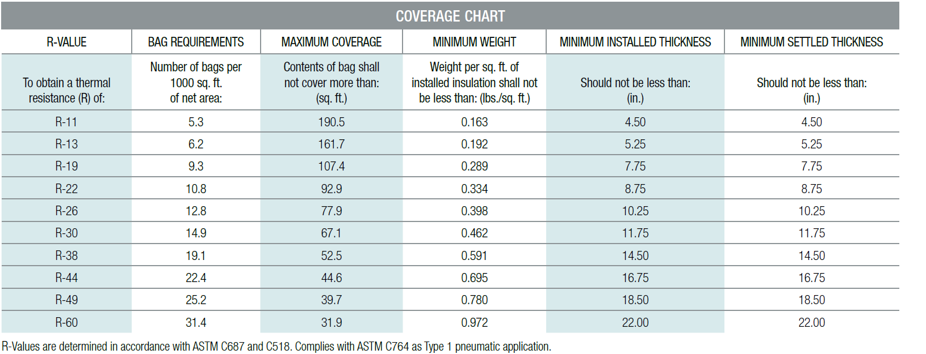

Closed Cavity (Walls, Floors, Ceilings) Retrofit Applications
